**Satellite**

In general, a satellite is a smaller object that revolves around a large object in space.

Natural and artificial satellites are the types of satellites. The natural satellite of earth is the moon.

**Communication satellite**

The communication refers to the exchange (storing) of information between two or more entities, through any medium or channel i.e. EM waves. In other words, it's nothing but sending and receiving and processing of information.

A satellite communication is an artificial satellite that relays and amplifies radio telecommunication signals via a transponder and it creates a communication channel between a source Transmitter and a destination receiver at different locations on earth.

Satellite communication consists of ground stations for transmitting and receiving signals and communication satellites in space. A satellite is simply a repeater. It consists of radio equipment active elements such as transmitter, receiver, antenna, signal processor, amplifier, transponder (a set of elements) and power is given by solar photovoltaic modules.

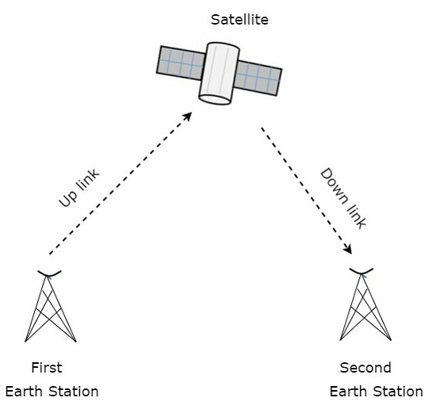

Figure: One-way satellite Communication

**History of Satellite**

Satellite Name Lunch Date Purpose

1. Sputnik I 4, Oct 1957 First artificial Satellite

2. Sputnik II 3, Nov 1957 Carries a dog Laika

3. Explorer-I 1, Feb 1958 First US Satellite

4. Explorer - II 5, Mar 1958 fail to reach orbit

5. SCORE 1 8, Dec 1958 christmas greeting to US people

6. Luna-1 2 Jan 1959 First man made satellite to orbit sun

7. Luna-2 12 sep 1959 First man made satellite to hit the moon

8. Luna-3 12 Sep, 1959 Pass close to moon

9. Tiros I 1, Apr, 1960 First meteorological satellite

10. Transit 1B 13, Apr 1960 First Navigation Satellite

11. Echo 12, Aug 1960 First passive satellite

12. Corona 18, Aug 1960 First us spy Satellite

13. Courier 4, Oct 1960 First active satellite

14. Vostok 12, Apr 1962 First carrier man in space

15. Telsat 10, Jul 1962 Transatlantic relaying

16. Mariner 14 Dec 1962 First planetary space to venus and enters a solar

orbit

17. Vostok-6 16 june 1963 First spacecraft carried women in space

18. Syncom I 14 Feb 1963 First geosynchronous communication

19. Syncom II 26 July 1963 First geo satellite

20. Syncom III 1 9 Aug 1964 Tokyo Olympics game transmit

21. Intelsat -I 6 Apr 1965 initially named early bird global FSS - Geo satellite,

a commercial satellite business opened.

**Satellite Communication Industry**

1. Intelsat

2. SES

3. Eutelsat

5. Iridium communication

6. Viasat

7. Hughes Network System

8 Telesat

9. Thuraya

10. Hispasat

**Emerging Satellite Company**

1. Starlink

Star link is a satellite internet constellation project developed by spacex, the aerospace company Founded by Elon Musk. The starlink constellation aims to provide global broadband coverage by deploying thousands of small satellites in low Earth orbit. About 3328 are in operation as of 2023 April. In total nearby 12,000 are planned to to be

deployed, with a possible. Later extension to 42,000 SpaceX announced reaching more than one million Subscribers in December 2022 and 1.5 million subscribers in May 2023.

**Some navigation Satellite**

1. Global positioning system (GPS) - USA
2. Global Navigation Satellite system (GLONASS) - Russia
3. Galileo - European union
4. BeiDou Navigation satellite system (BDS) China
5. NAVIC (Navigation with India Constellation) India
6. QZSS (Quasi Zenith Satellite system) -Japan

**Types of satellite**

1. The Satellite orbit types as inclination are:
2. Equatorial orbit 2. Polar Orbit 3. Inclined Orbit

(B) The Satellite orbit types are orbital height are:

1. LEO (Low Earth Orbit)
2. MEO Medium Earth orbit)
3. GEO (Geostationary earth orbit)
4. HEO (Highly Elliptical orbit)
5. HAP (High altitude platforms)

(C) The satellite orbit types as wrt the earth are

1. Geostationary (GEO)

2. Non-Geostationary orbit (NGSO)

(D) The satellite orbit types as characteristics

1. Circular orbit
2. Elliptical orbit

(E) The satellite Orbit types as wrt sun and earth

1. Sun synchronous
2. Geo synchronous

LEO, MEO and GEO

1. Parameters LEO MEO GEO
2. Satellite Height 500-1500 km 5000-12000 km 35786 Km
3. Orbital period 10-40 min 2-4 hours ~24 hours
4. Number of satellites 40-80 8-20 3

(Coverage)

1. The satellite life's span is short. Long. Long

(3-7) years (10-15)years (10-15)years

1. Cost very expensive expensive cheap
2. Propagation loss least High High
3. Atmospheric effect Most less less
4. Doppler shift More less Less
5. RTT (Round trip time) 20-25 ms 110-130 ms. 250-270 ms
6. Antenne size Small Medium Large

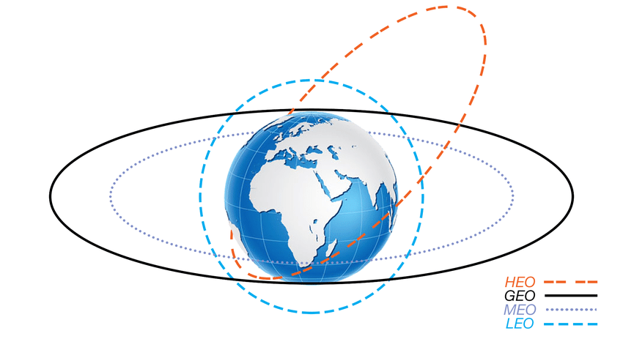

Figure : Satellite Orbit

[1] Low-Earth orbit (LEO) Satellite

LEO satellites lie much closer to the earth and range from 500 km to 1500 km above the earth's surface. It doesn't stay in a fixed position relative to the surface, and only visible for 15 to 20 minutes in each pass. A network of LEO Satellites is necessary for LEO satellites to be useful.

Advantages

1. Less time delay and better signal strength because of short range.
2. Less waste of bandwidth because of minimum area coverage
3. Better point to point communication.

Disadvantages

1. The LEO network is more required which can be costly because of minimum visibility.
2. More account of doppler shift
3. Atmospheric effect

[2] Medium Earth orbit (MEO) Satellite

MEO Satellites lie in between LEO and GEO satellites and range from 5000 km to 12000 km above the earth surface. It is visible for a much longer period of time than LEO satellites and usually visible for 2 to 8 hours for each pass. It is similar to the LEO satellite in functionality.

Advantages

1. Network of MEO is less required because of maximum visibility
2. Less account of doppler shift
3. Less atmosphere effects

Disadvantages

1. More time delay and bad signal Strength because of long range
2. More waste of bandwidth because of maximum area coverage.
3. Worse point-to-point communication.

[3] Geo- station Earth orbit (GEO) satellite

GEO Satellites lie far from the earth and are fixed at an orbit of 35786 km above the earth's surface along the equator objects in Geo- Stationary revolve around the earth at the same speed as the earth rotates. This means the GEO satellite remains in the same position relative to the surface of earth. Geo Satellites are synchronous with respect to earth. These satellites are placed in space in such a way that only three satellites are sufficient to provide connection through the surface of the earth.

Characteristics of GEO satellite:

1 Altitude: 35786.03 km

2. Period: 23 Hrs, 56min, 4.09 sec (same as earth)

3. Orbital inclination: 0°

4. Velocity: 3.075 km/sec

5. Coverage: 42.5% of earth's surface ( 3-satellites apart 120°)

6. Subsatellite point : On Equator

7. No coverage area: Beyond to 81°N and 77°S (If angle of elevation below 5° is eliminated)

Advantages

1. Network of GEO is not required because of 24 hours visibility.
2. Very less account of doppler shift.
3. Very less atmospheric effect
4. Simple ground station tracking.
5. No hand over problem
6. Long distance communication.
7. Nearly constant range
8. Low cost per added site
9. Availability, Flexibility and reliability
10. One ground segment is enough for the satellite monitoring
11. High covering area i.e. three satellite gives full earth coverage

Disadvantages

1. Much more time delay and very bad signal strength because of very long range
2. Much more waste of bandwidth because of very maximum area coverage
3. Very worse point to point communication
4. Free space loss
5. No polar coverage
6. Signal attenuation
7. Weather conditions
8. Initial cost is too high
9. Echo
10. Poor coverage at high attitudes (>77 degrees)
11. Transmission delay at the order 250 ms (high RTT latency)

(4) HEO (Molniya)

These satellites have been used by Russian for decades.

Molniya Orbit is an elliptical orbit. The satellite remains in a fixed position relative to earth for 8-hours. A series of three Molniya satellites can act like a GEO satellite. These satellites are useful in near polar regions.

(5) High altitude platforms (HAPs) satellite

HAPS are one of the newest ideas in Satellite Communication. A plane around 20 km above the earth's surface is used as a satellite. HAPs would have very small coverage and it

would have a comparatively strong signal.

These are cheaper to put in position but require a lot of them in a network.

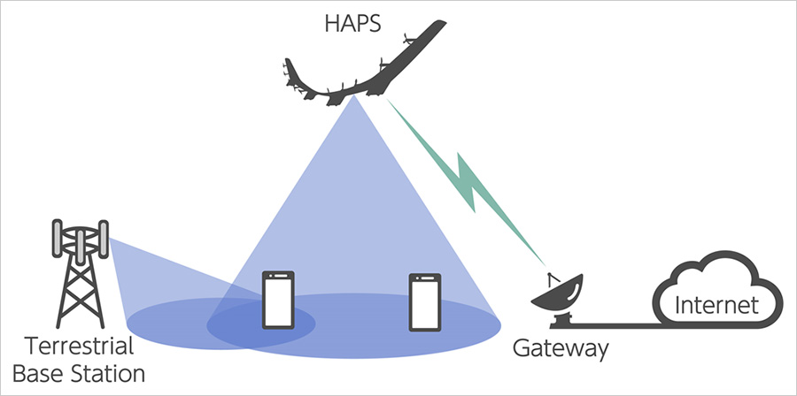

The satellite orbit types as inclination are:

1. Equatorial Orbits

Equatorial orbits lie exactly in the plane of the geographical equator of the earth i.e. the orbital path lies directly above the equator at all times.

The apparent orbital period of equatorial orbits is given as

P= (24T)/(24-T) hours.

where, T= real orbital period

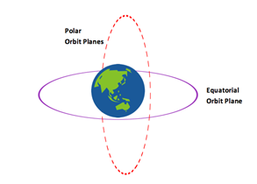Low area coverage

High spot beam

2. Inclination orbits

There are advantages and disadvantages to inclined orbits depending on the mission goals and the data recovery requirements. The greater the inclination of the orbits & the larger the surface area of the earth that the satellite will pass over at sometime in its flight. But the spot beam is low.

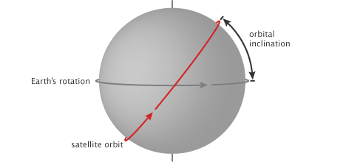

High area coverage

Low spot beam

3. Elliptical orbits

The schematic diagram of Elliptical orbit is shown in figure below (Kepler's first law)

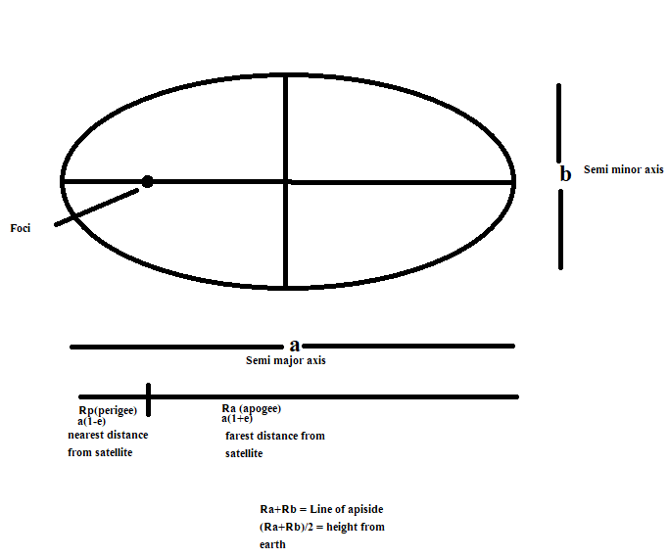

[C] Sun synchronous satellite Orbit [SSO]

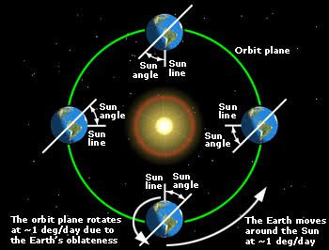

A sun synchronous Orbit is a special form of LEO where the plane of the orbit maintains a constant aspect angle with the direction to the sun.

It is a polar region of the earth.

**Round Trip Time (RTT) delay of GSS**

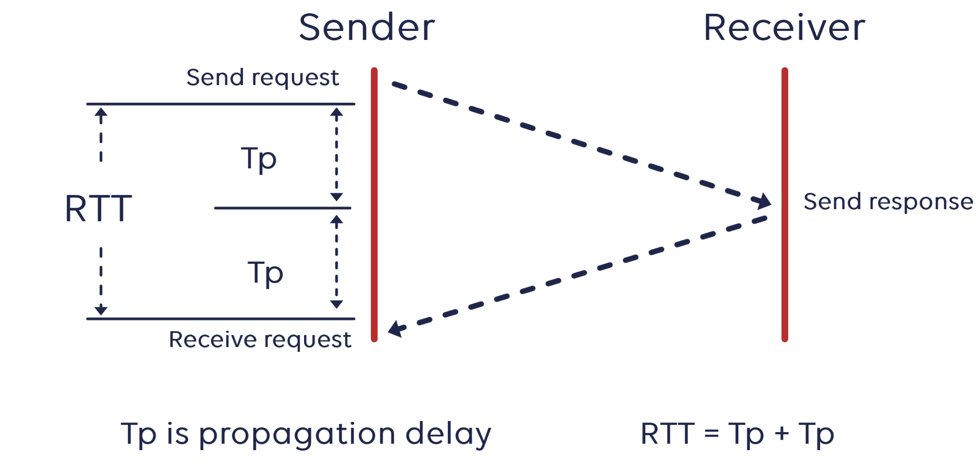

Round trip time delay, also known as latency, is the time taken for information to pass from the original to the destination and potentially for the response to return.

Round time delay in satellites is very much more obvious because of the very long distances that the signal travels into space and back.

The distance traveled depends on the location of the satellite and thus its Orbit.

RTT delay 2 x distance/velocity of light

Calculating a transmission's RTT has advantages because it allows. users and operators to identify how long a transmission will take to complete and how fast a network can operate.

**Constant value;**

1. acceleration due to gravity (9) = 9.8 m/s²

2. Gravitational Constant (G) = 6.67 + 10^-11 Nm²/kg²

3. mass of earth (me) = 5.975*10^24 kg

4. Equatorial height from earth surface (h) = 35786 km

5. Radius of earth (re) = 6378 km.

6. Kepler constant = Me × G (Nm²/kg)

7. Boltzmann Constant (k) = 1.38*10^-23 J/K

**As height increases ↑**

1. velocity of the object decreases
2. weight of the object decreases

(but mass remain constant)

1. Time period of the object increases

**Communication satellites (types)**

The satellites which are used for communication purposes are called Communication satellites.

(A) One-way link communication satellite

1. Broadcast satellite service

(FM, Radio and TV Broadcasting)

2. Data collection service

(meteorological data collection)

3. Earth Exploration Satellite service

(Remote sensing and mapping)

4. Meteorological satellite service

(meteorological data dissemination and weather forecast)

5. Radio determination Satellite service

(GPS, GLONASS) - Navigation

6. Reporting Service

(Disaster Monitoring and News Gathering)

7. Space operation Service

(Telemetry, Tracking and command Signal)

8. Safety Satellite service.

(Disaster, warning, Search and Rescue)

(B) Two way link communication Satellite.

1. Fixed Satellite service (FSS)

(telephone service and video conferencing)

2. Mobile Satellite service (MSS)

(aero-mobile, land mobile and Maritime communication)

3. Inter Satellite service (ISS)

(between-satellite to satellite communication)

4. Satellite News Gathering service (SNGS)

(portable & Transportable News Gathering)

**Q. How is it possible to put more than 220 operational satellites in GEO orbit?**

The Linear separation is → 2 degree, earlier it was 4° angle spacing

Different frequency bands have different spacing.

The position of satellite is maintained to within ±0.10

Perimeter of GEO orbit (P)

=2 x π x r

= 2× π (re+h)

=2 * π × (35786 + 6378)

=264924.2253 km

Thus 1° satellite spacing becomes = 2* π × r / 360°

=736 km

Hence, the satellite linear separation is 1472 km. So, the position of the Satellite is maintained to within ±0.10.

i.e. ±0.10 = ±73.6 km

**Frequency band used in satellite communication**

The range of frequencies used for transmission of signals, from ground stations to the satellite is called uplink frequency.

The range of frequencies used for transmission of signals from satellite to the ground station is called downlink frequency.

They are different to avoid interference.

Bands. Frequency (GHz) Application

L 1-2 MSS, TV, microwave applications

S 2-4 MSS, NASA, deep space research

C 4-8 FSS, microwave, terrestrial network

X 8-12.5 FSS, military communication metrology

Κυ 12.5-18 FSS, BSS. Fixed service terrestrial wave

K 18-26.5 FSS, Bss fIXed service terrestrial wave

Ka 26.5-40 FSS, Local multichannel distribution

| L | S | C | X | Ku | K | Ka |
| --- | --- | --- | --- | --- | --- | --- |

1 2GHz 4Ghz 8 Ghz 12.5GHz 18GHz 26.5GHz 40GHz



As the frequencies increase, throughput is higher.

As the frequencies increase, antenna size decreases.

As the frequencies increase, the spectrum band is higher.

As the frequencies increase, rain fading and interference is more.

From the above arrow line we can explain the characteristics, advantages and disadvantages of using 6/4 GHz frequency in satellite Communication.

**Radio window / Microware Window / space window**

The radio window is the range of frequencies of electromagnetic radiation that the earth’s atmosphere lets through. It is especially introduced in satellite communication systems. Radio widow frequencies range from 300 Mhz to 10 GHz. Frequencies below 300 Mhz, HF and VHF are affected by ionospheric effects such as D, and F layers and frequencies above 10 Ghz, EHF, SHF are affected by my are affected by tropospheric effect such as rain, cloud, fog, mist, dust particles in the sky and so on.

Why use higher frequencies in satellite communication?

Satellite communication systems are being designed to work at higher frequencies for a number of reasons.

1. Wide bands are required to cope with video conferencing and internet applications.

2. High transmission frequencies providing wide bandwidths.

3 There is already a large demand for existing 20-30 Ghz spectrum allocation, putting pressure on higher frequencies.

4. There is pressure on the spectrum of wide bandwidth at high frequencies, the next generation satellite communications are likely to use frequencies of 50 Ghz.

5. Other various reason's delays are reduced for higher frequencies.

**Frequency allocation by ITU**

Region 1 Europe, Africa, Formal USSR, Middle east, Mongolia

Region 2 North and South America, Greenland, West Indies

Region 3 South Asia, Asia pacific, Australia, South Pacific Islands

**# Why uplink frequencies greater than downlink frequencies in satellite communication?**

The signals have to cross the atmosphere which presents a great deal of attenuation.The higher the frequency, the more is the signal loss and more power is needed for reliable transmission.

A Satellite is a Lightweight device which cannot support high-power transmitters on it. So, it transmits at a low frequency (higher the frequency, higher is the transmitter power to accommodate losses) as compared to the stationary earth station which can afford to use very high power transmitters. This is compensated by using a highly sensitive receiver circuit on the earth station which is the line of sight of the satellite.

**Kepler's law of Planetary Motion**

Johannes Kepler (1571-1630) a German astronomer and scientist developed a quantitative description of the motion of the planets in the Solar system i.e. law of planetary motion.

1. Kepler's First law (the law of ellipse)

The orbit of any satellite body (earth) about a larger body (sun) is always an ellipse, with the center of mass of the larger body as one of the two foci.

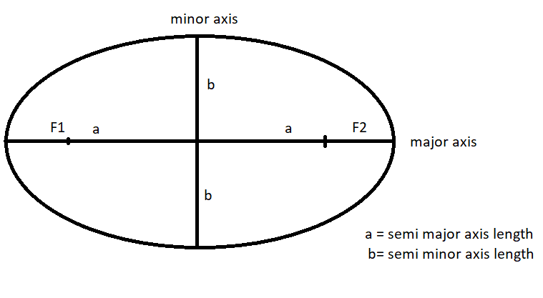

Figure : Kepler’s First Law

i.e. + = 1

The ellipse has two focal points (foci) F1 and F2, the center of the mass of the earth will always be present at one of the foci of the ellipse.

If the distance from the center of the object to a point on its elliptical path is considered, then the farthest point of an ellipse from the center is called apogee and the shortest point of an ellipse from the center is called perigee.

Eccentricity (e) =

2. The Law of equal area (Kepler's second law)

Assume that the satellite covers distance d1 and d2 in the same time interval then the area Aand A34 covered by the satellite at those two instances are equal.

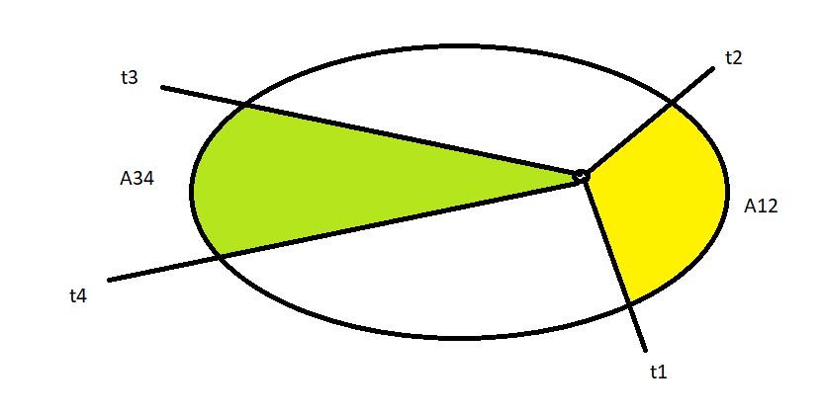

If t-t = t-t

d = d

Then A12 = A34.

(3) Kepler's third law

(the law of equal Harmonics)

States that the square of the periodic time of an elliptical orbit is proportional to the cube root of its semi- major axis length.

T a

T ka

T = a

Where, k = = proportionality constant

= Kepler’s constant

**Newton's law in satellite orbit dynamics**

Kepler's laws are wonderful as a description of the motions of the planets. However they provide no explanation of why planets move in this way. Kepler's third law i.e. law of equal harmonics only works for planets around the Sun and it doesn't apply to the moon's orbit around the earth or the satellite of Jupiter.

Newton provides a more general explanation of the motions of the planes through the development of Newton's law of motion and Newton's Universal law of gravitational.

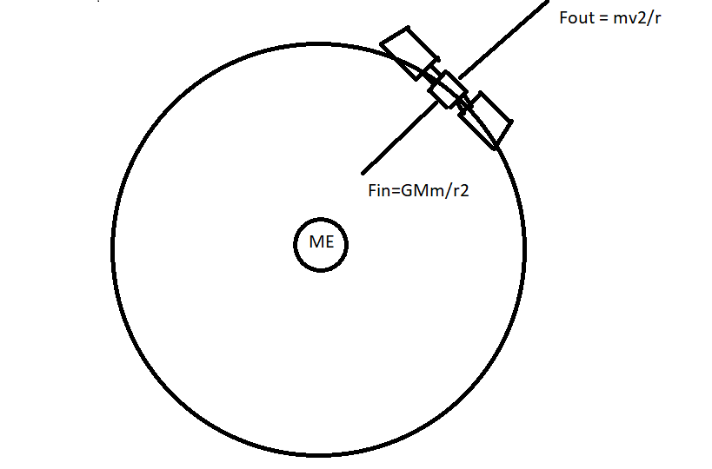

The magnitude of Gravitational force is given as,

F=

G = Universal Gravitational constant 6.67 * 10 Nm/kg

M= Mass of earth (5.975*10^24 kg)

also, F=mg.

Let m be the mass of satellite & v be the velocity of satellite

r = (re+h)

re = radius of earth

h= height from the earth satellite

The magnitude of centrifugal, fore is given as

F =

For any satellite in a circular orbit Gravitational force is equal to the centrifugal force

i.e.

=

GM =

= 6.67*

= 3.985*

Hence, = Kepler’s constant.

*Orbital velocity of GSS*

F= …………….. Equation (1)

F = ………………… Equation (2)

From equation 1 and 2, we get

v = = = 3.07 km/sec

Also,

Time period (T) =

= 23 hours 56 min and 4.04 sec

**The transponder**

Transponder is the component of the subsystem that receives the signal and shifts its frequency for transmission.

The subsystem provides the connecting link between transmitting and receiving antennas of a satellite.

It is one of the most important subsystems of space segment subsystems.

Transponder performs mainly two functions. Those are amplifying the received input signal and translates the frequency of it. In general, different frequency values are chosen for both uplink and downlink in order to avoid the interference between the transmitted and received signals.

The block diagram of the transponder is shown in the figure below.

Transmitter (Trans) + Responder (ponder)

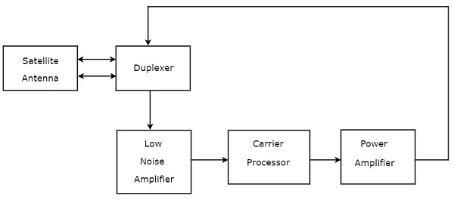

* 1. Duplexer is a two-way microwave gate. It receives uplink signal from the satellite antenna and transmits downlink signal to the satellite antenna.
* 2. Low Noise Amplifier (LNA) amplifies the weak received signal.
* 3. Carrier Processor performs the frequency down conversion of received signal (uplink). This block determines the type of transponder.
* 4. Power Amplifier amplifies the power of frequency down converted signal (down link) to the required level.

Types of transponder

Basically, there are two types of transponders. Those are Bent pipe transponders and transponders.

1. Bent PipeTransponders

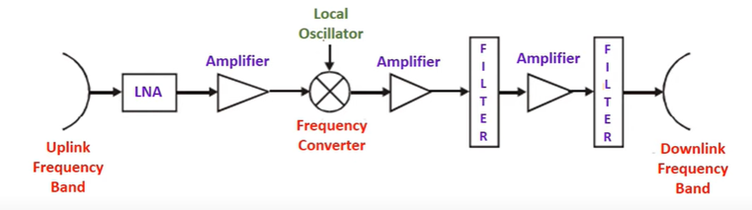

Bent pipe transponder receives a microwave frequency signal. It converts the frequency of input signal to RF frequency and then amplifies it. Bent pipe transponder is also called a repeater and conventional transponder. It is suitable for both analog and digital signals.

### 

### Regenerative Transponders

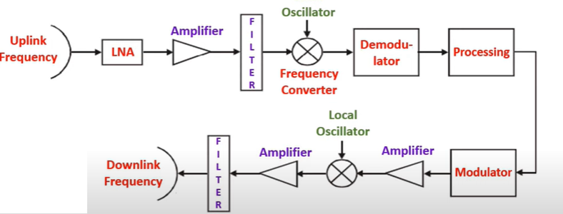

Regenerative transponder performs the functions of Bent pipe transponder. i.e., frequency translation and amplification. In addition to these two functions, Regenerative transponder also performs the demodulation of RF carrier to baseband, regeneration of signals and modulation.

Regenerative transponder is also called a Processing transponder. It is suitable only for digital signals. The main advantages of Regenerative transponders are improvement in Signal to Noise Ratio (SNR) and have more flexibility in implementation.

**Footprints**

The area of the earth covered by the microwave radiation from a satellite dish (transponder) is called the satellite footprints. The area of earth that can be seen by a particular satellite is called satellite footprints. i.e. area covered by the satellite on earth's surface or the area with which a satellite in the earth orbit can communicate.

A footprint can be as large as an entire country, continent,etc.

The size of the footprint depends on the location of the satellite in its orbit, the shape and size of the beam produced by its transponder and the distance from the earth.

The footprint can be seen as, the area in which a broadcast signal from a particular satellite can be received and the area of the surface of the earth within a satellite transponder (transmitter or sensor) field of view.

The signal power at the center of the foot print is maximum. The power decreases as we move from the footprint center. The boundary of the footprint is the location where the power reaches a predefined threshold.

Spot beam is also a kind of footprint focused high power satellite signal that covers only a small region.

Outside the footprint area, the signal is undetectable, and will not interface with other uses of the same wavelength.

Footprint the RF beam pattern on earth surface.

Hence, the radiation patterns of satellites on particular surfaces of earth stations are called footprints.

Satellites beam their signals in a straight path to the earth. The satellite focuses these microwaves signals onto the specified portions of the earth's surface to most effectively use the limited power of their transponders. These focused signals create a unique beam pattern called footprints.

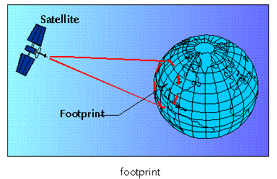

**Satellite stabilization**

If a satellite is not stable then it will swing about in an unpredictable way which is very hard to satellite communication. Hence, stabilization is required in satellite communication. To make a satellite stable the factors such as velocity, position and altitude must need to be controlled.

Techniques used to maintain satellite stability

1. Spin stabilization
2. Three axis stabilization

**Satellite Antenna**

The device which is used to connect electric signals into electromagnetic waves and vice-versa is called an antenna.

Antenna used in satellite communication

1. Wire antenna
2. Horn antenna
3. Reflector antenna

**Life of satellite**

1. Probability of survival

* Flight experience of many years
* Highly reliable parts and materials are used.
* Highly accurate and flexible needed for all parts
* Transponder probability should not be less than 0.7.
* Every parts and materials are to meet probability to unity

1. Probability of failure

At initial phase state and end of life probability of failure rate is high and whereas failure rate is low during life of satellite.

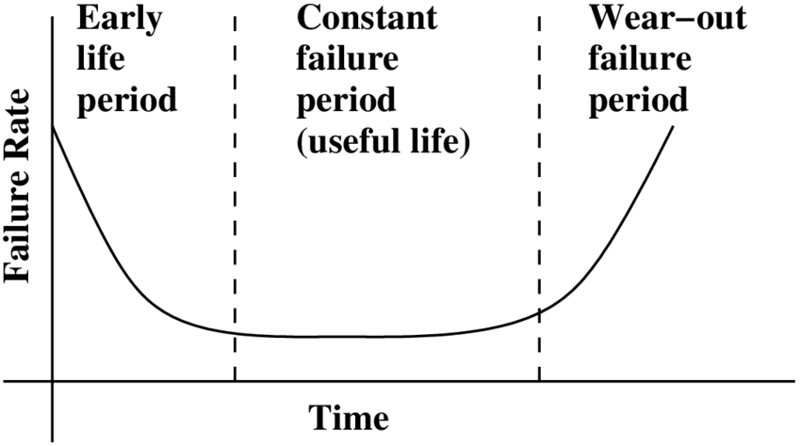

1. Satellite life vs fuel

* Fuel is essential for satellite life, it is like blood in humans.
* Fuel is consumed for correction
* Fuel is gas Hydrazine (N2H4) in the form of liquid.
* Thrusters (small rocket engines) are used to correct satellite position.
* Unwanted fuel loss if not correct launch window is chosen.

1. Battery life vs Satellite life

* Battery supply is mostly consumed during lunch and Eclipse
* Eclipses occur twice per year around spring/summer (70 min eclipse duration in march 21 and september 21 each year) and fall equinox (when earth's shadow passes across the spare craft)
* Battery site is gradually losing charge and operating at passing age typically battery voltage is 20 to 50V. (Nickel Hydrogen battery instead of NiCd battery because of light weight)

1. Satellite vs Solar Cells

* Solar cells output gradually decrease 20% after satellite lifespan of 8-10 years
* after some period Turning off some transponders to extend satellite life by limited power from solar cells
* High quality cells are used i.e. GaAs is mostly used for this purpose.

1. Satellites like vs lunch windows

* Particular period of time, time is everything.
* Satellite camera Rocket should be launched at the correct time.
* At the launch window, spacecraft are easier to place.

1. the INTELSAT-V launch window calculation.

* Sun Angle apogee motor firing attitude = +/-5 degree.
* Eclipse 30 minute
* Sun angle in injection attitude = +/- 24 degree
* sun/earth sensor Interference = +/- 2.5 degree

**Satellite Link design**

The requirements for satellites are very precise and satellites must be capable of operating in simple condition while still maintaining the highest standard of reliability because they cannot be recovered from maintenance repair.

The facts consideration for the satellite link design are

1. Small and lightweight.
2. Acceleration
3. center of mass
4. Minimum power consumption
5. Orbit
6. Alignment of satellite and Solar panel
7. Merge and placement of Hardware
8. Precise location of every part.
9. Planning: Budget, time limitation, full technical support, system development planning

Hence these factors are most essential for the satellite link design

**Propagation in communication**

1. Surface wave propagation
2. Space wave
3. Sky wave

Layers of earth

1. Troposphere (8 to 14.5 km)
2. Stratosphere (14.5 to 50 km)
3. Mesosphere (50 to 85 km)
4. Thermosphere (85 to 600 km)
5. Exosphere (600 to 10000 km)

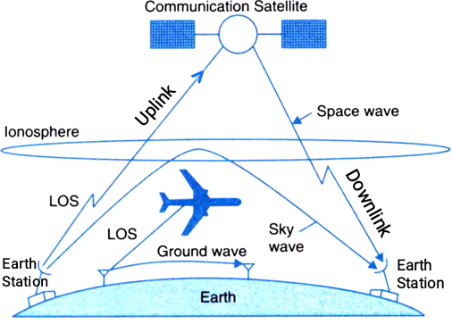

**Basic Transmission theory / Friis transmission equation**

In satellite communication, the power of the transmitting antenna and the power of the receiving antenna are to be calculated.

i.e. the received power,

Pr = Pt Gt Gr Watts

In Terms of decibel

[Pr] = 10 log(Pt) + 10 log(Gt) + lo log (Gr) - Lfs

Where,

Pr = Received power

Gr= Gain of receiving antenna

Pt = transmitted power

Gt = Gain of transmitting antenna

r = distance between Rx and Tx

= wavelength of frequency used

Lfs = Free space loss

= 10log

V = velocity * wavelength

**Signal to noise Ratio i.e. S/N or (Carrier to Noise Ratio i.e. C/N)** (Satellite System Parameter)

The ratio of desired signal to added noise signal is called signal to Noise Ratio. The changes in signals occur during their transmission, propagation and reception. Noise signal adding proportions to propagation distance.

A measure of performance of satellite link is the ratio of Carrier power to the noise power at the receiver input and link budget calculations are often concerned with determining this ratio.

It is denoted by (C/N) or (P/P) and expressed in terms of decibel.

The [C/N] of the satellite is given as,

[C/N] = (P/P) ………………equation (1)

In terms of dB we get,

[C/N] = (P/P)

[C/N] = (P) - (P) …………………. equation (2)

Where, [P] = Received power

= [EIRP] + [G] - [Other Losses]

[EIRP] = Equivalent Isotropic radiated power = [PG

= [P] + [G (in decibel)

P = Antenna power (input)

G= Transmit antenna gain

The available noise power for thermal noise source is given as

P K TB……………… equation (3)

where, k= Boltzmann constant (1.38*10^-23 J/K

B = Noise Bandwidth (BW)

T = Noise temperature.

In terms of dB,

(P) dB = (K) dB + (T) dB + (B) dB ………….. Equation (4)

Substituting these valves in equation (5) we get,

[C/N] = (P) - (P)

= [EIRP] dB + [G] dB - [Other Losses] dB -[K] dB - [T] dB - [B] dB

Also we have,

The parameter which specifies the receiving system is given as,

[ ] dB = []dB -[TdB ……………………. Equation (6)

Substituting these values in equation (5) we get,

[C/N] = [EIRP] dB + [] dB - [Other Losses] dB -[K] dB - [B] dB

Losses = [FSL] + [RFL] + [AML] + [AA] + [PL]

Where, FSL = Free space loss (in dB)

RFL = Receiver feeder loss (in dB)

AML = Antenna misalignment loss (in dB)

AA = atmospheric absorption loss (in dB)

PL = polarization mismatch loss (in dB)

The Gain of parabolic antenna in given as,

G= ()

= area

Where, D = diameter of antenna

F = frequency operating

= antenna efficiency

Area = = area of parabolic antenna

= =values lies between 0.5 to 0.8

[G]dB =10 log[ ()]

= 10log+20 log(f) + 2 log (D) + 20.4 dB

**Equivalent Noise Temperature**

Te = To (NF-1)

where, Te = equivalent noise temperature (K).

To = temperature of environment

NF = noise factor.

**Transmit power and Bit energy**

Eb = Pt. Tb

Where, Eb = energy of a signal bit.

Pt = total carrier power.

fb = bit rate.

Tb = time of a single bit.

**Applications**

1. Weather forecasting
2. Radio and TV Broadcast
3. Navigation and GPS
4. Miliitory, Spy
5. Tele-medicine
6. Data communication
7. Remote sensing and mapping
8. Teleconference
9. Standard time
10. Connecting remote areas
11. Satellite to satellite communications
12. E-mail, internet and file transfer
13. Telemetry, tracking and command signal
14. Meteorological data dissemination (spreading information)
15. Learning, business and agriculture

**Numerical**

A Japanese Satellite "JCSAT-3" is located in geostationary orbit at 128 degree East . What would be the orbital velocity and orbital time period of rotation of it?

Solution,

h= 35786 km

radius of earth (re) = 6378 km

we have,

GMm/r² = mv²/r

v = √GM/r

=√(6.67×10-¹¹)(5.975×10²⁴)/(35786+ 6378)×10³

= 3076.59 m/s

=3.07 km/sec

Time period (T) = ( 2 × π × r)/v

= 86294 sec

=23 hrs 58 min 14 sec.